Devsoft Baltic OÜ Website Terms Of Use

Introduction
Please read these website terms of use (“TERMS OF USE”) and privacy statement carefully before using SurveyJS websites (“WEBSITES”), property of Devsoft Baltic OÜ (“DEVSOFT”). TERMS OF USE govern your access to and use of the WEBSITES. If you do not agree to all of the TERMS OF USE and PRIVACY STATEMENT set forth below, do not use the WEBSITES. By accessing or using the WEBSITES, you and the business entity or the organization you represent (“YOU” or “YOUR”) indicate your agreement to be bound by the TERMS OF USE.

Scope
The TERMS OF USE govern your use of the WEBSITES and all content, examples, and services (collectively, “CONTENT”) available via the WEBSITES, except to the extent such CONTENT is the subject of a separate agreement. Note that the use of SurveyJS Project software product (“SURVEYJS”) is governed solely by the License Agreement under which it is licensed. Always check the License Agreement to make certain that neither you nor your software application infringe the intellectual property rights of DEVSOFT or others. DEVSOFT reserves the right to modify and update its PRIVACY STATEMENT and TERMS OF USE as needs dictate and as legal requirements are updated. If and when a change is made to our PRIVACY STATEMENT or TERMS OF USE, this page will be duly updated to reflect the change. Your continued use of the WEBSITES after any changes to these PRIVACY STATEMENT and TERMS OF USE will mean that you accept those changes.

Privacy statement

DEVSOFT Respects Your Privacy
DEVSOFT does not lend, lease, sell, or market information it obtains from its customers or those who provide us with personally identifiable information. DEVSOFT does not disclose purchase information or licensing information to third parties.

Data Retention and Access

While you have a SurveyJS account, we retain data associated with your account and store it using Azure cloud storage service. This includes survey data and account data. All customer data is stored on servers located in the United States. SurveyJS customers should notice that the data is only accessed from inside Europe to provide customer and billing support from our European office.
We may retain the data associated with your account after the account has been deleted as required by applicable law. For example, since all SurveyJS developer licenses are perpetual, we retain license owner data, including their name, email address associated with the license(s), company name and VAT, type and quantity of the licenses purchased. This information is retained and used for the following reasons:
- To identify license owners, who are entitled for a discount for renewal subscription (for updates and technical support) pertaining to existing license(s)
- To comply with our legal obligations.
- To enforce our agreements
- To resolve disputes
In these cases, we ensure that access to the data is blocked except for the purposes for which we have been required to retain the information.
We also retain information that you publicly share in the public and private Help Desk tickets, e.g., questions and comments. Data published in private tickets is deleted upon a written request to info@devsoftbaltic.com.

Deletion and Restoration of Account and Data

Deleting an Account
You can delete your account and survey data associated with it at any time. To delete an account, please go to the Delete Account section on your Account page, click the Delete button and follow the instructions.

Deleting a Survey
In order to delete a particular survey, you need to archive it first. SurveyJS customers should be aware that survey archiving is irreversible. In order to archive a survey, please go to the My Surveys page, expand the details section using the arrow icon on the left of the survey title, and click Archive.
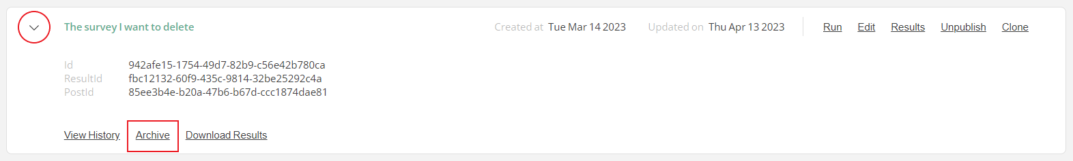

Now that the survey has been archived, switch to the Archived tab and click Delete. 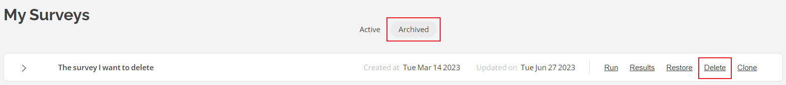

Deleting Survey Results
You can delete the results of active and archived surveys. Partial results deletion is not available. In order to delete the results of a survey, identify it in the list of active or archived surveys, and click Results.
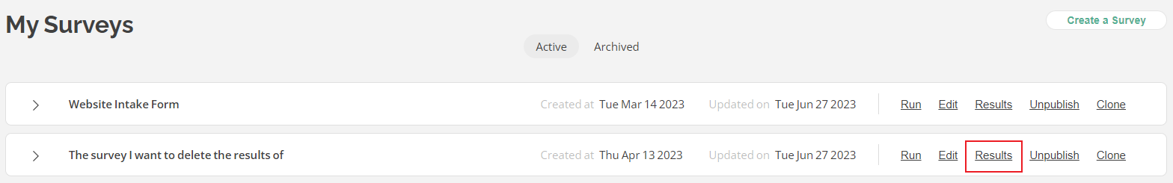

In the Results page, switch to the Info tab and click the Clear Results button.
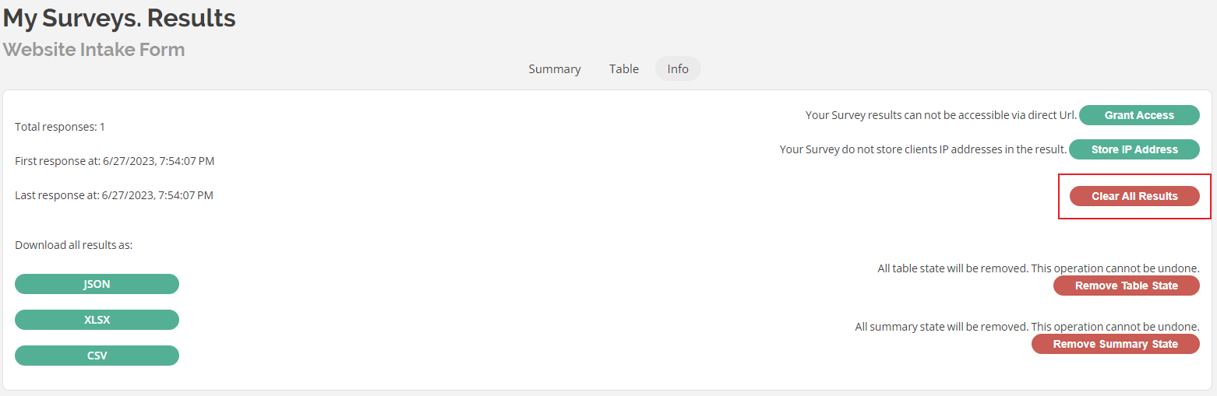

Whilst analyzing the survey data, you can customize the way it is presented, e.g. hide or reposition certain table columns, limit access to them, etc. If you make changes to an active survey and the survey data cease to display, it is recommended to reset the data display settings to their default state by clicking Reset Table State and Reset Summary State - whichever you customized.
Once deleted, the survey data won’t be accessible, and you will not be able to restore it.
We honor deletion requests for both an account and its data. The deleted account and survey data associated with it is permanently removed from our system immediately without the possibility of recovery.

Email Communication
When creating an account with SurveyJS, you can agree to receive information about new products, important updates, and occasional surveys and special offers from Devsoft Baltic OÜ via email. The subscription for marketing emails is optional. To unsubscribe from receiving marketing materials, click the unsubscribe link placed at the bottom of the email you received and follow the instructions.


Alternatively, you can submit your request at support@surveyjs.io. Please be aware that you will still be sent a number of non-marketing emails that you cannot unsubscribe from (for example, order and renewal confirmations, license transfer notifications, etc.).

Cookies Notice

What is a Cookie?
Cookies are small bits of data we store on the device (computer, mobile phone, tablet or any other mobile device) that you use to access SurveyJS websites (“WEBSITES”), so we can recognize repeat users. Each cookie expires after a certain period of time depending on what we use it for.
In this Cookies Notice, we use the word “cookies” as a catchall term to include not only cookies, but also other technologies such as pixels, web beacons and page tags. Like most commercial websites we use cookies on SurveyJS web pages.
We use cookies for several reasons. Below we list and describe the various types of cookies we use on our websites.

What Cookies Do We Use?
Below we list the different types of cookies that may be used on the WEBSITES.
The websites use both first party cookies (which are set by the WEBSITES being visited) and third party cookies (which are set by a server located outside the domain of our WEBSITES).

Why Do We Use Cookies?
We use cookies and similar technologies for several reasons:

To gather metrics
For example, we will collect data about the search terms users entered in the search box, the average time a user spends on the WEBSITES, what pages users viewed within a single visit, whether they scrolled down the entire page or left it in the middle, and other details about their visit to the WEBSITES. We also record clicks of certain buttons to determine whether the product is intuitive enough so as to improve the overall user journey. This information is collated and kept at an aggregated, pseudonymized level.

To make our site easier to use
If you use the “Remember me” feature when you sign into your account, we store your username in a cookie to make it quicker for you to sign in whenever you return to our site.

For security reasons
We use cookies to authenticate your identity and confirm whether you are currently logged into our site or determine if an incident impacts you.

To provide you with personalized content
We store user preferences, your default language, device and browser information, so we can identify you across devices and personalize the content you see.

To improve our services and track our campaigns
We use cookies to analyze and measure your visits to and exploration of our websites and track referral data. This information helps us to develop and improve our services (it helps us focus on the parts of the service you seem most interested in), to optimize the content we display online and also to track the success of marketing campaigns.

Google Analytics
We use Google Analytics as a tool to measure the success of our advertising campaigns and referrals through third party advertising partners. The Google Analytics data collected for these purposes is aggregated and anonymous.
Where you have explicitly consented, or have not disabled third party advertising cookies (depending on your location), we will also use Google Analytics data to support display advertising, including re-targeting. You can customize the Google Display Network ads by using the Google Ad Preferences Manager and learn more about how Google serves ads by viewing its Customer Ads Help Center.

Required Cookies
(Example: a cookie used for login authentication)
Certain cookies are necessary in order for the WEBSITES to operate correctly and remain secure, to ensure essential functionality, to measure and analyze site traffic at the aggregate level and to stabilize the WEBSITES. We have to load required cookies for legitimate interests pursued by us in delivering essential functionality of our WEBSITES to you and your respondents.

Functional Cookies
(Example: a cookie that stores your language preference)
These cookies collect information about your choices and preferences, and collect information about your use of the WEBSITES which enable us to improve functionality. For example, these cookies help us record any difficulties you have with the Sites, and show us whether our advertising is effective or not. In some cases these cookies allow us to see the overall patterns of usage on the WEBSITES, rather than the usage of a single person (except where that is part of the necessary function of the cookie).

Advertising Cookies
(Example: cookies set from domains corresponding to our marketing affiliates, like ads.twitter.com or ads.google.com or facebook.com or ads.reddit.com or stackoverflow.co)
We may use cookies to market our services to you on third party websites or to measure and track the effectiveness of our marketing efforts so that we can tailor our advertising more effectively.

How Do I Manage Cookies?
Users can remove or disable cookies within their browser settings. The settings and steps for managing cookies vary by browser, so we suggest referring to your browser’s documentation. One important note is that if you do go this route, this might adversely impact your ability to use our services effectively. Enabling certain types of cookies ensures a smoother experience when you use our site.
To learn more about how to disable cookies you can refer to this external website: https://www.aboutcookies.org/.
If you separately use cookies or similar technologies on your site in conjunction with our products, you are independently responsible for management of the data collected through those cookies and for compliance with all laws related to usage of these technologies.

Legal, Copyright, and Trademark

Information
All intellectual property rights associated with the WEBSITES and their CONTENT are the sole property of DEVSOFT. The CONTENT is protected by European and International copyright laws. All DEVSOFT Service Marks so designated and all DEVSOFT Products referenced on the WEBSITE are either trademarks or registered trademarks of DEVSOFT. All custom graphics, icons, and other items that appear on the WEBSITES are trademarks, service marks or trade dress of DEVSOFT and may not be used in any manner without the express written consent of DEVSOFT. DEVSOFT has made every effort to supply third-party trademark information on the WEBSITES. All third party trademarks represented on this WEBSITE may be the property of their respective owners. Certain areas of the WEBSITES may contain other proprietary notices, conditions of use, and copyright information, the terms of which must be observed and followed. Except for the rights of use and other rights expressly granted by these TERMS OF USE or SURVEYJS licensing terms, you may not copy, reproduce, modify, lease, loan, sell, create derivative works from, upload, transmit, or distribute the intellectual property of the WEBSITES in any manner without the prior written consent of DEVSOFT. DEVSOFT grants you a limited, personal, non transferable, revocable license which cannot be sub- licensed to access and use the WEBSITE and its CONTENT only in a manner expressly authorized by DEVSOFT and the TERMS OF USE. Except to the extent required by law, the CONTENT made available on the WEBSITE may not be reverse-engineered, modified, reproduced, republished, translated into any language, re-transmitted in any form or by any means, resold or redistributed without the prior written consent of DEVSOFT. You may not make, sell, offer for sale, modify, reproduce, display, publicly perform, import, distribute, retransmit or otherwise use the CONTENT in any way, unless expressly permitted to do so by DEVSOFT.

Your Submissions
DEVSOFT does not wish to receive, act to procure, nor desire to solicit, confidential or proprietary materials and information from you through the WEBSITES. Any and all materials or information divulged during chats, phone calls, email communication or made available to DEVSOFT in any manner will be deemed not to be confidential by DEVSOFT. You acknowledge that submissions to DEVSOFT will not be considered confidential or proprietary and that DEVSOFT will be under no obligation to keep such information confidential. You further acknowledge that DEVSOFT will have an unrestricted, irrevocable license to use, reproduce, display, perform, modify, transmit and distribute such materials or information, and you also agree DEVSOFT is free to use any ideas, concepts, know-how or techniques that you send to us for any purpose.

Outbound Links
The Website may contain links and references to non-DEVSOFT websites and resources (“EXTERNAL SITES”). Links to EXTERNAL SITES are provided for informational purposes and in no way represent an endorsement or approval by DEVSOFT. DEVSOFT makes no representations or warranties regarding the validity or quality of any content, software, or service hosted on any EXTERNAL SITE. You agree that use of EXTERNAL SITES is done so at your own risk.

Termination
DEVSOFT, at its sole discretion, may terminate your access and use of all or any portion of the WEBSITE and its CONTENT at any time, with or without cause. Upon such termination, you must immediately discontinue the use of the WEBSITE.

Disclaimer of Warranties
THE CONTENT PROVIDED ON THE WEBSITES AND ALL RELATED COMMUNICATIONS ARE PROVIDED ON AN “AS IS” BASIS. IN ADDITION, ALL WARRANTIES ARE HEREBY DISCLAIMED, INCLUDING THE IMPLIED WARRANTIES OF MERCHANTABILITY, FITNESS FOR A PARTICULAR PURPOSE, OR NON-INFRINGEMENT. SOME JURISDICTIONS DO NOT ALLOW THE EXCLUSION OF IMPLIED WARRANTIES, SO THE ABOVE EXCLUSION MAY NOT APPLY TO YOU. The CONTENT provided on the WEBSITES may contain technical inaccuracies or typographical errors. CONTENT, including but not limited to pricing, licensing terms may be changed or updated without notice. DEVSOFT may also make improvements and/or changes in the products described in this information at any time without notice.

Limitation of Liability
To the extent permitted by applicable law, in no event shall DEVSOFT be liable for any special, incidental, indirect, or punitive and consequential damages(including, without limitation, damages for loss of business profits, business interruption, loss of business information, or any other pecuniary loss) arising out of the use of or inability to use the WEBSITES and associated CONTENT, even if DEVSOFT has been advised of the possibility of such damages. You understand that the CONTENT made available on the WEBSITES may produce inaccurate results. You assume full and sole responsibility for any use of the WEBSITES and its CONTENT and bear the entire risk for failures or faults.You agree that regardless of the cause of failure or fault or the form of any claim, YOUR SOLE REMEDY AND DEVSOFT’S SOLE OBLIGATION SHALL BE GOVERNED BY THIS AGREEMENT AND IN NO EVENT SHALL DEVSOFT’S LIABILITY EXCEED THE PRICE PAID FOR THE SERVICES RENDERED VIA THE WEBSITES.

Mutual Indemnification
DEVSOFT and YOU shall each indemnify, defend and hold the other party and their respective directors, officers, employees and agents harmless from all liabilities, costs and expenses (including, without limitation, attorneys fees) that either of the two parties may suffer, sustain or become subject to as a result of YOUR use of the WEBSITES, including but not limited to your violation of these TERMS OF USE.

Miscellaneous
The TERMS OF USE shall be governed by, construed, and interpreted in accordance with the laws of the Republic of Estonia, without giving effect to any principles of conflicts of law. The TERMS OF USE give you specific legal rights; you may have others that vary from state to state and from country to country. DEVSOFT reserves all rights not specifically granted in the TERMS OF USE.Should you have any questions concerning this document, or if you desire to contact Devsoft Baltic OÜ for any reason, please contact us directly at info@devsoftbaltic.com or write: Maakri tn 19/1-7K, Kesklinna district, Tallinn city, Harju county, 10145, Republic of Estonia.

Copyright Notice
Copyright © 2015-2023 Devsoft Baltic OÜ. All rights reserved.

Trademarks
The SURVEYJS logo and icon and all Devsoft Baltic OÜ product names, icons and trademarks represented on this website are property of Devsoft Baltic OÜ. Microsoft, Windows, Visual Studio, Visual Code are trademarks or registered trademarks of Microsoft Corporation. Apple, iOS, iPhone and iPad are trademarks or registered trademarks of Apple Inc. Google and Android are trademarks or registered trademarks of Google Inc. All other trademarks or registered trademarks are property of their respective owners.

